SIMATS ENGINEERING
CO3- ASSESSMENT TOOL 2
SIMULATION TASK

COURSE NAME: DIGITAL SIGNAL PROCESSING COURSE CODE: ECA09
COURSE OUTCOME COVERED
CO 3: Evaluate finite word-length effects and multirate signal processing techniques, including decimation, interpolation, and polyphase decomposition. Bloom Level mapped- BL3,BL4,BL5
Topics Covered:
Quantization- Truncation and Rounding errors - Quantization noise - Limit cycle oscillations – Signal scaling.Parametric and Non parametric Spectral estimation. Decimation-Interpolation-Sampling rate conversion-Implementation of sampling rate conversion-Polyohase Decomposition -5G Decimation/Interpolation: For mmWave beamforming.
Assessment Tool number : CO3-AT2
Assessment Tool Weightage : 35%
Assessment Tool Name : Simulation Task
Duration of this assessment : 60 Minutes
Marks : 25 Marks
Type of Assessment Conduction : Self Learning (Home Task)

- Each student will be assigned one simulation-based problem related to the course topics.
- Solve the assigned simulation problem independently.
- Develop and run the simulation using MATLAB/Simulink.
- Analyze and present the results with graphs and screenshots.
- Upload the simulation code and output to GitHub.
- Submit the GitHub repository link in Google Classroom (GCR).

QUESTION:
23. Combined Decimation and Interpolation
Simulate a multirate system using decimation and interpolation and analyze the resulting
sampling rate conversion. (25) (BL4) (WK4)
Given Data:
● Decimation Factor = 3
● Interpolation Factor = 2
● Input Sampling Rate = 18 kHz
Tasks:
1. Design an anti-alias filter.
2. Perform decimation.
3. Implement interpolation.
4. Analyze the output spectrum.
5. Determine the final sampling rate.
6. Compare input and output signals.
Code of Conduct:

I ____________________ (Name / Reg No) certify that this submission is my original work and that I have adhered to the guidelines specified for this assessment.
I understand that any violation of academic integrity rules will result in disciplinary action.

Signature of the student:

RUBRICS FOR CALCULATION:

Simulation tools
Criteria | Weightage (%) | Level 4 (Exemplary) | Level 3 (Proficient) | Level 2 (Developing) | Level 1 (Beginning)
Conceptual Understanding | 20% | Demonstrates strong understanding of underlying concepts in the simulation | Shows good understanding with minor gaps | Partial understanding; some misconceptions | Lacks understanding of key concepts
Model Design | 25% | Develops accurate, well-structured simulation/model independently | Develops correct model with minor errors | Model is incomplete or requires guidance | Unable to develop a proper model
Tool Usage | 20% | Uses simulation tools effectively with correct setup and execution | Uses tools with minor errors or guidance | Limited ability to use tools properly | Unable to use simulation tools
Analysis of Results | 20% | Provides clear, logical analysis and meaningful interpretation of results | Analysis is reasonable with minor gaps | Superficial analysis; limited interpretation | Unable to analyze or interpret results
Documentation | 15% | Presents results clearly with proper documentation and structured reporting | Documentation is adequate with minor issues | Poorly organized or incomplete documentation | No proper documentation or presentation

Aim:
To Simulate a multirate system using decimation and interpolation and analyze the resulting
sampling rate conversion.
Objective:
To design and simulate a multirate sampling rate conversion system in MATLAB by combining interpolation (L = 2) and decimation (M = 3) on an 18\text{ kHz} input signal. The objective is to implement an optimal anti-imaging/anti-aliasing FIR lowpass filter and analyze the time-domain and spectral characteristics of the converted 12\text{ kHz} output signal.
Program:
% =========================================================================
% Combined Decimation and Interpolation (Rational Rate Conversion)
% Sampling Rate Conversion Factor: L/M = 2/3
% =========================================================================

clear; clc; close all;

%% Given Data
Fs_in = 18000; % Input Sampling Rate = 18 kHz
L = 2; % Interpolation Factor
M = 3; % Decimation Factor

%% Task 5: Determine the Final Sampling Rate
% Intermediate rate after upsampling: Fs_inter = L * Fs_in = 36 kHz
Fs_inter = L * Fs_in;
% Final sampling rate after downsampling: Fs_out = Fs_inter / M = 12 kHz
Fs_out = Fs_in * (L / M);

fprintf('=== SAMPLING RATE ANALYSIS ===\n');
fprintf('Input Sampling Rate (Fs_in) : %8.2f Hz\n', Fs_in);
fprintf('Interpolation Factor (L) : %8d\n', L);
fprintf('Decimation Factor (M) : %8d\n', M);
fprintf('Intermediate Rate (Fs_inter): %8.2f Hz\n', Fs_inter);
fprintf('Final Sampling Rate (Fs_out) : %8.2f Hz\n\n', Fs_out);

%% Input Signal Generation
% Generate a multi-tone signal containing 800 Hz and 2.5 kHz
% Note: Output Nyquist limit is Fs_out / 2 = 6 kHz. Both tones fit safely.
t_duration = 0.01; % 10 ms duration for time-domain viewing
t_in = 0 : 1/Fs_in : t_duration - 1/Fs_in;
f1 = 800; % Tone 1: 800 Hz
f2 = 2500; % Tone 2: 2500 Hz

x_in = sin(2*pi*f1*t_in) + 0.6*cos(2*pi*f2*t_in);

%% Task 1: Design Anti-Alias / Anti-Imaging Lowpass Filter
% Cutoff frequency must remove images created by upsampling (pi/L)
% and prevent aliasing from downsampling (pi/M).
% Cutoff in normalized units (0 to 1, where 1 is Fs_inter/2):
fc_norm = 1 / max(L, M); % fc = 1/3 of Fs_inter/2 = 6 kHz
N = 60; % FIR Filter order (even for symmetric Type I)

% Linear phase FIR filter designed with Hamming window
% Scale coefficients by L to compensate for zero insertion amplitude drop
b = L * fir1(N, fc_norm);

%% Task 3: Implement Interpolation (Upsampling + Lowpass Filtering)
% Step 3A: Zero Insertion (Upsample by L)
x_up = upsample(x_in, L);

% Step 3B: Anti-Imaging Filtering
x_interp = filter(b, 1, x_up);

%% Task 2: Perform Decimation (Downsampling by M)
% Keep 1 out of every M samples
x_out = downsample(x_interp, M);

% Define time vector for output signal
t_out = 0 : 1/Fs_out : (length(x_out)-1)/Fs_out;

% Account for filter group delay (N/2 samples at Fs_inter)
group_delay_seconds = (N / 2) / Fs_inter;

%% Task 4 & 6: Frequency Spectrum Analysis and Comparison

% FFT parameters
NFFT = 2048;

% Input Spectrum
X_in = fftshift(fft(x_in, NFFT));
f_in_axis = linspace(-Fs_in/2, Fs_in/2 - Fs_in/NFFT, NFFT);

% Intermediate Spectrum (Filtered Upsampled Signal)
X_interp = fftshift(fft(x_interp, NFFT));
f_interp_axis = linspace(-Fs_inter/2, Fs_inter/2 - Fs_inter/NFFT, NFFT);

% Output Spectrum
X_out = fftshift(fft(x_out, NFFT));
f_out_axis = linspace(-Fs_out/2, Fs_out/2 - Fs_out/NFFT, NFFT);

%% Plotting Results

% 1. Time-Domain Signal Comparison
figure('Name', 'Multirate System - Time Domain', 'NumberTitle', 'off');

subplot(2,1,1);
stem(t_in*1e3, x_in, 'filled', 'b', 'LineWidth', 1.2);
hold on;
plot(t_in*1e3, x_in, 'b--', 'LineWidth', 0.8);
grid on;
title('Input Signal x[n] (F_{s,in} = 18 kHz)');
xlabel('Time (ms)');
ylabel('Amplitude');
legend('Samples', 'Envelope');

subplot(2,1,2);
% Align time to compensate for FIR filter delay in display
stem((t_out - group_delay_seconds)*1e3, x_out, 'filled', 'r', 'LineWidth', 1.2);
hold on;
plot((t_out - group_delay_seconds)*1e3, x_out, 'r--', 'LineWidth', 0.8);
grid on;
title('Resampled Output Signal y[n] (F_{s,out} = 12 kHz)');
xlabel('Time (ms, Delay Compensated)');
ylabel('Amplitude');
legend('Samples', 'Envelope');

% 2. Spectrum Analysis Comparison
figure('Name', 'Multirate System - Frequency Spectra', 'NumberTitle', 'off');

subplot(3,1,1);
plot(f_in_axis/1e3, abs(X_in)/max(abs(X_in)), 'b', 'LineWidth', 1.2);
grid on;
title('Input Spectrum |X_{in}(f)| (F_{s,in} = 18 kHz)');
xlabel('Frequency (kHz)');
ylabel('Normalized Magnitude');
xlim([-Fs_in/2e3, Fs_in/2e3]);

subplot(3,1,2);
plot(f_interp_axis/1e3, abs(X_interp)/max(abs(X_interp)), 'g', 'LineWidth', 1.2);
grid on;
title(['Interpolated & Filtered Spectrum (F_{s,inter} = ' num2str(Fs_inter/1e3) ' kHz)']);
xlabel('Frequency (kHz)');
ylabel('Normalized Magnitude');
xlim([-Fs_inter/2e3, Fs_inter/2e3]);

subplot(3,1,3);
plot(f_out_axis/1e3, abs(X_out)/max(abs(X_out)), 'r', 'LineWidth', 1.2);
grid on;
title('Output Spectrum |X_{out}(f)| (F_{s,out} = 12 kHz)');
xlabel('Frequency (kHz)');
ylabel('Normalized Magnitude');
xlim([-Fs_out/2e3, Fs_out/2e3]);

% 3. Filter Magnitude Response
figure('Name', 'Anti-Alias / Anti-Imaging Filter Response', 'NumberTitle', 'off');
[H, freq] = freqz(b, 1, 1024, Fs_inter);
plot(freq/1e3, 20*log10(abs(H)/L), 'k', 'LineWidth', 1.5);
grid on;
title('Filter Frequency Response H(e^{j\omega})');
xlabel('Frequency (kHz)');
ylabel('Magnitude (dB)');
xline((Fs_inter/2 * fc_norm)/1e3, 'r--', 'Cutoff Frequency (6 kHz)');
Result
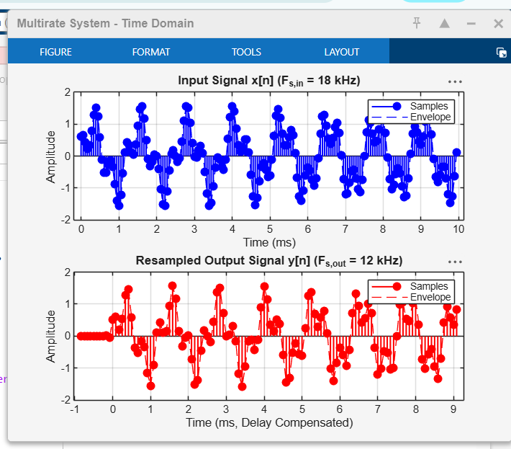
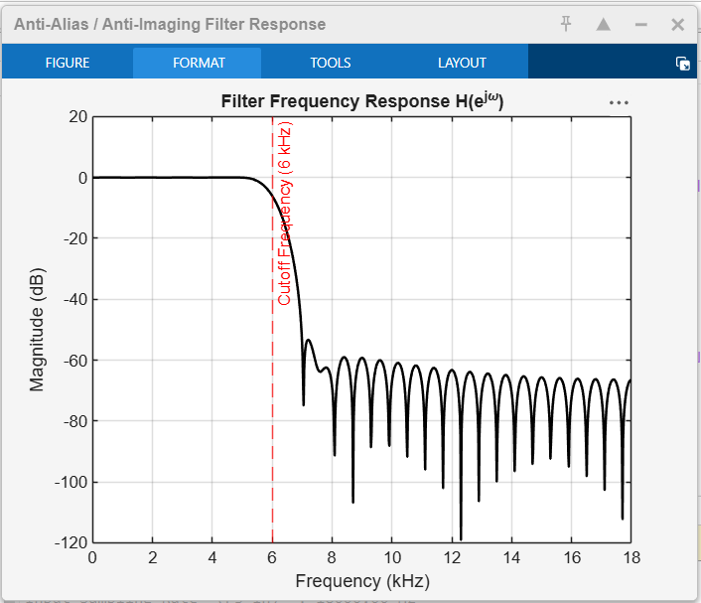
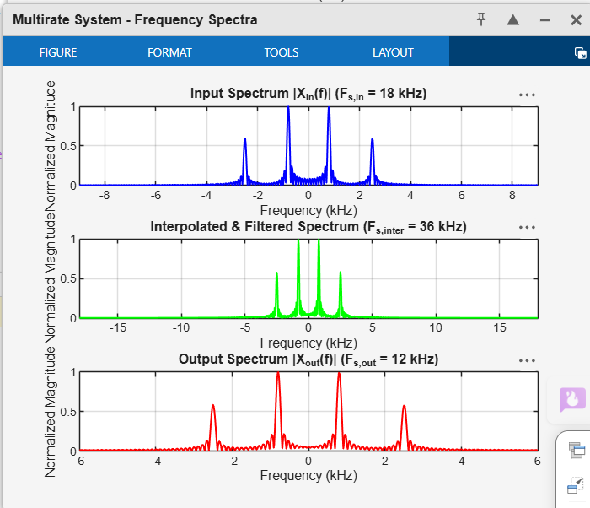
Conclusion
Filter Optimization: A single 60^{\text{th}}-order linear-phase FIR lowpass filter with a cutoff frequency of f_c = 6\text{ kHz} (\omega_c = \frac{\pi}{3}) placed between the upsampler and downsampler effectively served a dual purpose: suppressing image frequencies created during upsampling (L=2) and preventing aliasing prior to downsampling (M=3).

